COA24-979 SECOND DISTRICT
NORTH CAROLINA COURT OF APPEALS
****************************************************
STATE OF NORTH CAROLINA )
)
v. ) From Martin County
)
JERMAINE JACKSON )
****************************************************

DEFENDANT-APPELLANT’S BRIEF
****************************************************

INDEX
TABLE OF AUTHORITIES ii

ISSUES PRESENTED 1

STATEMENT OF THE CASE 2

GROUNDS FOR APPELLATE REVIEW 3

STATEMENT OF FACTS 3

STANDARDS OF REVIEW 7

ARGUMENT 8

- The trial court committed per se error when it allowed the jury to convict Mr. Jackson of a crime on which it did not instruct the jury 8
- The trial court reversibly erred when it deviated from the pattern instruction and omitted the required language specifying the manner of driving in the reckless driving element of the operating a motor vehicle to elude arrest instruction 12
- The trial court reversibly erred when it deviated from the pattern instruction and omitted the willfulness element in its felony and misdemeanor hit and run instructions 17

CONCLUSION 21

CERTIFICATE OF COMPLIANCE 23

CERTIFICATE OF FILING AND SERVICE 23

APPENDIX

TABLE OF AUTHORITIES

Statutes

N.C.G.S. § 7A-27(b) 3
N.C.G.S. § 15A-1443(a) 7
N.C.G.S. § 15A-1444(a) 3
Rules

N.C. R. App. P. 30(e) 11

Other Authorities

N.C.P.I.—Crim. 270.54A 12
N.C.P.I.—Crim. 270.80 12
N.C.P.I.—Crim. 270.80 n.2 12, 13
N.C.P.I.—Crim. 270.81 12
N.C.P.I.—Crim. 271.54 17, 18

COA24-979 SECOND DISTRICT
NORTH CAROLINA COURT OF APPEALS
****************************************************
STATE OF NORTH CAROLINA )
)
v. ) From Martin County
)
JERMAINE JACKSON )
****************************************************

DEFENDANT-APPELLANT’S BRIEF
****************************************************
ISSUES PRESENTED
- The trial court committed per se error when it allowed the jury to convict Mr. Jackson of a crime on which it did not instruct the jury.
- The trial court reversibly erred when it deviated from the pattern instruction and omitted the required language specifying the manner of driving in the reckless driving element of the operating a motor vehicle to elude arrest instruction.
- The trial court reversibly erred when it deviated from the pattern instruction and omitted the willfulness element in its felony and misdemeanor hit and run instructions.

Statement of the Case
A Martin County Grand Jury returned indictments against Mr. Jackson for fleeing to elude arrest and assault on a law enforcement officer resulting in physical injury (21 CRS 50769); two counts of felony hit and run (21 CRS 50770); assault on a female and battery on an unborn child (21 CRS 50771); resisting a public officer and reckless driving (21 CRS 50772); and habitual felon status (22 CRS 13). Before trial, the State declined to proceed on the charges in 21 CRS 50772. The remaining charges were tried during the 4 December 2023 Criminal Session of Martin County Superior Court before Judge Wayland J. Sermons.
At the close of the State’s evidence, the trial court granted Mr. Jackson’s motion to dismiss one count of felony hit and run pertaining to Shakeya Jones, and the charges of assault on a female and battery on an unborn child. On 6 December 2023, the jury found Mr. Jackson guilty of felonious fleeing to elude arrest, a lesser included of misdemeanor assault on a law enforcement officer, and a lesser included of misdemeanor hit and run and failure to stop. Mr. Jackson pled guilty to having attained habitual felon status.
The trial court sentenced Mr. Jackson to a sentence of 72 to 99 months’ imprisonment to run concurrent to a second sentence of 120 days. Mr. Jackson gave oral notice of appeal.

GROUNDS FOR APPELLATE REVIEW
Mr. Jackson appeals pursuant to N.C.G.S. §§ 7A-27(b) and 15A-1444(a).
Statement of Facts
Early the morning of 14 November 2021, Patrol Officer Brandon Raynor, who had been working as an officer for about ten months, went to the parking lot behind City Café, a bar and dance club in Williamston. (Tp 26) Raynor received a report of a possible fight. (Tpp 26, 62) No weapon involvement was indicated in the call. (Tp 62) When Raynor arrived, there were 30 to 40 people standing in the parking lot. (Tp 26) Raynor said the some of the crowd looked like it was rocking back and forth, and he heard yelling among the crowd and assumed something was going on in the middle of that crowd. (Tpp 26-27) Raynor approached a group of three men in the crowd that included someone he knew and started talking to him to get an idea about what was going on. (Tp 28) Body worn camera footage indicated no apparent emergency. (State’s Ex. 6)
While talking to the three men in the parking lot, Raynor testified he heard what he believed to be a gun being chambered “in the right diagonal side of my body” and turned that way. (Tp 28) When Raynor turned, there was a gray pickup truck 40-50 feet away with its brake light activated and there were a few people standing in the area as well. (Tpp 31, 65, 66) Raynor went up to the truck “to speak with any occupants inside and to look inside of the vehicle to make sure that there was not -- he was not – any occupant inside the vehicle was not actively pointing the gun at someone or was trying to shoot somebody.” (Tp 31)
Jermaine Jackson was sitting in the driver’s seat of his truck in the City Café parking lot. (Tp 33) Officer Raynor went up to his truck, shone a flashlight in his face, and cursed at him about a gun “click.” (State’s Ex.6 WFC1120794_18831316.avi at 00:49-00:54) Mr. Jackson made both his hands visible and tried to tell Raynor to “chill” and “settle down.” (State’s Ex.6 at 00:54-01:01; Tpp 33-34, 63) Raynor then began screaming at Mr. Jackson, trying to look into the truck, and ordering Mr. Jackson out of his truck. Raynor said Mr. Jackson’s voice got “real high pitched, real—real irate,” so Raynor grabbed the truck’s door handle and opened the driver side door of Mr. Jackson’s truck and tried to physically pull Mr. Jackson’s body out of Mr. Jackson’s truck, where moments before Mr. Jackson had been sitting peaceably with friends. (Tpp 34, 63) Body worn camera footage shows that fewer than ten seconds elapsed between when Raynor approached the truck and Raynor yanked open the truck’s door. (State’s Ex. 6)
At some point after Raynor opened Mr. Jackson’s truck door and began trying to yank Mr. Jackson from his vehicle, Mr. Jackson pushed the truck’s gas pedal. (State’s Ex. 6 at 01:05) Mr. Jackson drove out of the parking lot and took a right onto East Boulevard. Raynor never saw a gun, and no gun was recovered. (Tpp 76-77, 98) When Mr. Jackson drove away, the portion of the truck’s frame that connects the front driver’s side door to the rear driver’s side door struck Raynor’s arm and “kind of pulled me forward a little bit,” which left bruising on Raynor’s hand and some swelling on his forearm. (Tpp 37, 40; RSupp 2-6) The entire interaction between Raynor and Mr. Jackson lasted approximately twenty seconds. (State’s Ex. 6)
After Mr. Jackson drove away, Raynor headed back to his patrol vehicle and eventually saw Shakeya Jones, who was visibly pregnant, lying on the ground near where Mr. Jackson’s truck had been. (Tp 46) Jones testified she had been at City Café as a designated driver with some family members. (Tp 84) As she was leaving, she was looking for a man named Deandre Stokes, who was friends with Mr. Jackson, so she went over to Mr. Jackson’s truck, where Stokes was in the passenger seat. (Tpp 84-85) Jones was talking to Stokes through the open front passenger door. Jones did not know whether Mr. Jackson was aware she was in the passenger doorway. (Tp 87) When Mr. Jackson drove away, the passenger truck door swung back in to close and knocked Jones down. (Tp 89) Jones had scrapes on her skin from the fall and went to the hospital because her blood pressure was elevated; there were no lasting complications to her or her child’s health. (Tp 90) Jones never saw or heard a gun in Mr. Jackson’s truck. (Tpp 98, 99)
Officer Banks, who came to City Café a minute or less after Raynor, testified he followed Mr. Jackson after he left the parking lot. Banks estimated Mr. Jackson was driving “[a]t least 70 miles per hour” on East Boulevard, which has a 45mph speed limit. (Tp 114) Banks saw the truck take a wide turn and hit a light pole fifteen to twenty feet off the roadway. (Tp 114) Banks approached the truck, saw Stokes running from the truck, followed Stokes, and eventually took Stokes into custody. (Tp 115) Mr. Jackson was arrested later the same day. (Tpp 154-55)
At the close of the State’s evidence, the trial court granted Mr. Jackson’s motions to dismiss on the felony hit and run count pertaining to Jones and the charges of assault on a female and battery on an unborn child pertaining to Jones.
Defense counsel requested lesser-included instructions on “misdemeanor flee to elude and misdemeanor assault on a government official and also misdemeanor hit and run.” (Tp 181) All three were included on the verdict sheets given to the jury as “misdemeanor fleeing to elude arrest,” “misdemeanor assault on a law enforcement officer,” and “misdemeanor hit and run and failure to stop,” respectively. (Rpp 13-14) The jury returned guilty verdicts for “feloniously fleeing to elude arrest,” misdemeanor assault on a law enforcement officer, and misdemeanor hit and run and failure to stop. (Rpp 13-14) Mr. Jackson pled guilty to having attained habitual felon status and was sentenced to 72 to 99 months’ imprisonment for the felony, which was consolidated with the misdemeanor assault conviction, to run concurrent to a 120-day sentence for the misdemeanor hit and run conviction.

STANDARDs OF REVIEW
Where a trial court omits part of or fails to give an agreed upon pattern jury instruction, that substantive deviation is automatically preserved for appellate review, “notwithstanding any failure to bring the error to the trial judge’s attention at the end of the instructions.” State v. Ross, 322 N.C. 261, 265 (1988); see also State v. Lee, 370 N.C. 671, 675-76 (2018) (deviation from agreed upon pattern instruction is automatically preserved for appellate review). Preserved challenges to the trial court’s jury instructions are reviewed de novo. State v. Osorio, 196 N.C. App. 458, 466 (2009).
Where, as in Issue I, an agreed upon pattern instruction is wholly omitted and the jury returns a verdict on the charge not instructed on, the error is per se prejudicial, and this Court does not apply harmless error review. State v. Bowen, 139 N.C. App. 18, 26 (2000).
Where, as in Issues II and III, an element or portion of an agreed upon pattern instruction is omitted, this Court must determine whether, absent the error, there is a reasonable possibility the outcome would have been different. N.C.G.S. § 15A-1443(a); State v. Ramos, 363 N.C. 352, 355-56 (2009).

argument
- The trial court committed per se error when it allowed the jury to convict Mr. Jackson of a crime on which it did not instruct the jury.

The jury was instructed on felonious assault on a law enforcement officer inflicting physical injury. (Tpp 206-07) This was the only assault charge on which the jury was instructed. In fact, the court’s mandate following the felony assault instruction told the jury that if “[i]f you do not so find or have a reasonable doubt as to one or more of these [felony assault elements] it will be your duty to return a verdict of not guilty.” (Tp 207)
Nevertheless, the verdict sheet reflected both the charge of felonious assault on a law enforcement officer inflicting physical injury and the lesser included charge of misdemeanor assault on a law enforcement officer in addition to a not guilty option. (Rp 13) And, despite never being instructed on the misdemeanor charge, the jury rejected the felony charge and convicted Mr. Jackson of the misdemeanor charge. Because the jury was never instructed on that charge, the jury had no information about what the State was required to prove for misdemeanor assault on a law enforcement officer or how that charge differed substantively from the felony assault charge on which the jury was instructed. (Rp 13) Contrast Tp 205 (explicitly stating how misdemeanor hit and run “differs from the felonious hit and run with injury in that it is not necessary that the State prove beyond a reasonable doubt that the defendant knew or reasonably should have known that the collision resulted in injury to a person”).
Defense counsel requested the instruction on misdemeanor assault on a government official. (Tp 181) The court considered its inclusion (Tp 181), acknowledged defense counsel’s intent to argue in favor of the misdemeanors, conducted the corresponding Harbison inquiries (Tpp 183-84, 197), and included the misdemeanor option on the verdict sheet (Rp 13). Despite these discussions between the court and the parties and the fact the misdemeanor was presented on the verdict sheet as an option for the jury, the jury was never instructed on the elements of misdemeanor assault on an officer or told how it was different from the felony assault crime on which they were instructed. Instead, the jury was only instructed on felonious assault on a law enforcement officer inflicting physical injury, a crime for which the jury acquitted Mr. Jackson.
A jury simply cannot convict a defendant of a crime not presented to it in instructions. This is so, because such an error “is a basic violation of due process.” State v. Walker, COA17-357, 2017 N.C. App. LEXIS 916, *6 (N.C. Ct. App. Sept. 6, 2017) (unpublished) (citing Bowen, 139 N.C. App. at 26 (quoting State v. Williams, 318 N.C. 624, 629 (1986))). Indeed, a trial court’s failure to instruct the jury on a charge amounts to a dismissal of the charge. Williams, 318 N.C. at 628; Bowen, 139 N.C. App. at 26. Thus, conviction on the basis of a functionally dismissed charge is the type of error that is so fundamental the error is prejudicial per se and requires reversal. Bowen, 139 N.C. App. at 26; see also, e.g., State v. Hudson, 280 N.C. 74, 79 (1971) (discussing the “fundamental principle . . . that ‘[n]o person shall be convicted of any crime but by the unanimous verdict of a jury in open court.’” (quoting N.C. Const. art I, § 24)).
This argument is preserved for appeal by defense counsel’s request for the instruction. (Tp 181) See Ross, 322 N.C. at 265 (stating “a request for an instruction at the charge conference is sufficient compliance with the rule to warrant our full review on appeal where the requested instruction is subsequently promised but not given, notwithstanding any failure to bring the error to the trial judge’s attention at the end of the instructions.”); Lee, 370 N.C. at 675-76 (similar). In Bowen this Court explicitly rejected the State’s argument that the usual harmless error review should apply when a trial court fails to give an instruction as to a particular charge. Bowen, 139 N.C. App. at 26 Instead, this Court recognized the inherently prejudicial nature of being convicted by a jury of charge on which that jury was never instructed and held that even where the evidence supports the conviction, the indictment and the verdict sheet are consistent, and no objection is made, a conviction obtained without any instruction is a “‘basic violation of due process’” and must be vacated. Id. (quoting Williams, 318 N.C. at 629); see also Hudson, 280 N.C. at 79; cf. State v. Petersen, 350 N.C. 518, 533-34 (1999) (finding no error where Court determined there was no conflict between the “Issues and Recommendation as to Punishment” form and oral instructions given by the court). Indeed, our appellate courts have time and again found such errors to require reversal. See Williams, 318 N.C. at 631; Bowen, 139 N.C. App. at 26; State v. Davidson, COA16-272, 2016 N.C. App. LEXIS 1077, *6-8 (N.C. Ct. App. Nov. 1, 2016) (unpublished); Walker, 2017 N.C. App. LEXIS 916, *6 (unpublished). This Court should do so again here.
The acceptance of a jury verdict and entry of judgment against a defendant for an offense for which the jury was not instructed is “more than erroneous; [it is] a basic violation of due process.” Bowen, 139 N.C. App. at 26 (quoting Williams, 318 N.C. at 629). Such errors cannot stand. “[T]he fairness and justice upon which our judicial system is based” requires vacatur of Mr. Jackson’s conviction. Id. Because the erroneous assault conviction was part of a consolidated judgment, the case must be remanded for resentencing. See Lineberger v. N.C. Dep’t of Corr., 189 N.C. App. 1, 18 (2008); Davidson, 2016 N.C. App. LEXIS 1077, *9 (unpublished).

- The trial court reversibly erred when it deviated from the pattern instruction and omitted the required language specifying the manner of driving in the reckless driving element of the operating a motor vehicle to elude arrest instruction.

A description of the manner of driving underlying the reckless driving element of operating a motor vehicle to elude arrest “is necessary to avoid reversible error.” N.C.P.I.—Crim. 270.80 n.2 (citing Ingle v. Transfer Corp., 271 N.C. 276 (1967)). Here, the trial court skipped over that mandatory portion of the instruction.
Properly given, when using the reckless driving factor, the pattern instruction in 270.54A requires the court to incorporate the definition of reckless driving from N.C.P.I.—Crim. 270.80 or 270.81:
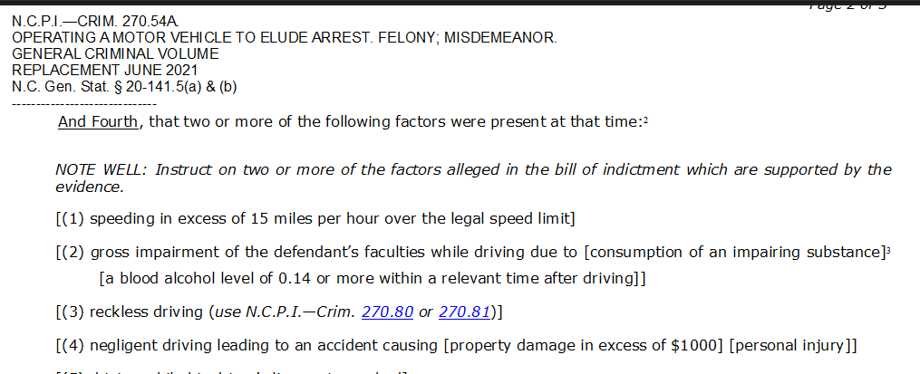
N.C.P.I.—Crim. 270.54A. Here, the court incorporated the definition from N.C.P.I.—Crim. 270.80, but only included part of it, when it told the jury the fourth element was satisfied if the jury concluded “the defendant engaged in reckless driving in that he drove carelessly and heedlessly in willful or wanton disregard to the rights or safety of others.” (Tp 203) Comparing that language to the pattern instruction reproduced below, however, demonstrates the court failed to include the mandatory parenthetical describing the manner of driving before completing the definition with the language about acting carelessly and heedlessly in willful or wanton disregard of the rights or safety of others.
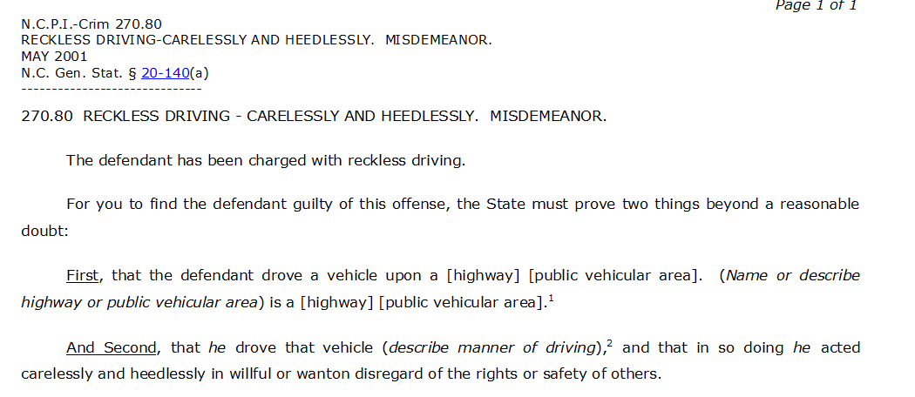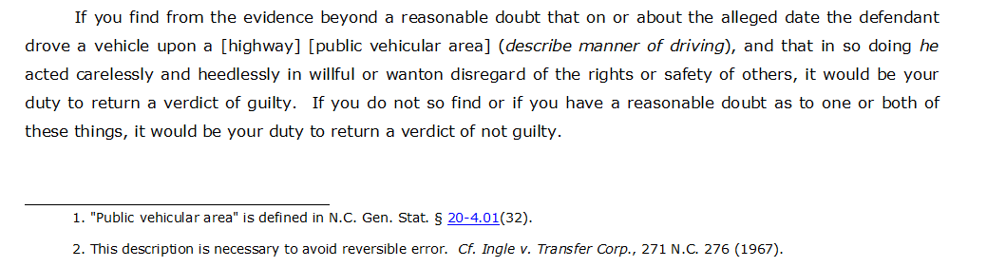
By failing to describe the manner of driving the jury was to consider in determining the reckless driving element, the trial court deviated substantively from the pattern instruction. This omission was error, and, as the pattern instruction footnote above indicates, reversible error. N.C.P.I.—Crim. 270.80 n.2.
While “[f]ailure to follow the pattern instructions does not automatically result in error,” error does result where the failure to follow the pattern instruction results in an inadequate explanation of “each essential element of an offense.” State v. Bunch, 363 N.C. 841, 846 (2010). “The purpose of a jury instruction ‘is to give a clear instruction which applies the law to the evidence’ and thus ‘assist[s] the jury in understanding the case and in reaching a correct verdict.’” Lee, 370 N.C. at 676, (quoting State v. Williams, 280 N.C. 132, 136 (1971)). Further, a defendant is entitled to a jury trial as to every element of the crime charged, and that obligation can only be satisfied when a jury is instructed on each of the elements. See, e.g., Bunch, 363 N.C. at 846; State v. Field, 75 N.C. App. 647, 648 (1985); State v. Williams, 295 N.C. 655, 674 (1978); State v. Lewis, 274 N.C. 438, 442 (1968). Here, the trial court failed to define correctly or explain the reckless driving element of the alleged felony.
The court’s error effectively relieved the State of its burden to prove one of two required factors for reckless driving. As given, the instruction constituted exactly what our Supreme Court warned against in Ingle: “[A]llegations as to reckless driving . . . without specifying wherein the party was reckless amount to no more than an allegation that the party charged was negligent.” Ingle, 271 N.C. at 283. A court must “tell the jury what facts they might find from the evidence would constitute reckless driving,” as it is “not sufficient for the judge to read the statute and . . . leave it to the jury to apply the law to the facts and to decide for themselves what defendant’s driver did, if anything, which constituted reckless driving.” Roberts v. Pilot Freight Carriers, Inc., 273 N.C. 600, 609 (1968). The court’s error here did just that: the jury was left to apply the law to the facts themselves and decide what actions constituted reckless driving. See Ford v. Jones, 6 N.C. App. 722, 725 (1969); Nance v. Williams, 2 N.C. App. 345, 350 (1968); Roberts, 273 N.C. at 609; Ingle, 271 N.C. at 284.
The State made no specific argument about the manner of driving that constituted reckless driving in its motion to dismiss response, instead generalizing about actions that are not in and of themselves reckless driving or catering only to the second part of the recklessness definition. (Tp 172 (arguing Mr. Jackson “slammed on the gas in a crowd of people, spun the wheels, slung his car around in a reckless and disregard – to recklessly and disregard the safety of the others in the parking lot”)) The State declined to move forward on the independent reckless driving indictment. (Tpp 174-75) And the jury was never instructed on what aspect of Mr. Jackson’s driving might constitute the type of driving or action required for reckless driving.
In the absence of instruction on the manner of driving component of the reckless driving element of felony fleeing to elude, the jury properly could have found Mr. Jackson guilty, at most, of the lesser included misdemeanor operation of a motor vehicle to elude arrest, which does not require a finding of reckless driving. (Tp 204 (misdemeanor lesser included instruction)). There is a reasonable possibility this instructional error changed the outcome of the case because it allowed the jury to convict Mr. Jackson of felony operating a motor vehicle to elude arrest—abbreviated on the judgment “ELUDE ARRST MV 2 AGRVTG FCTRS” (Rp 21)—while only finding one of the two aggravating factors required to elevate the charge from a misdemeanor to a felony. The difference between what was sentenced as a Class D felony (72 to 99 months) and what should have been, at most, a Class 1 misdemeanor (120-day max) is difficult to overstate. Had the State been properly held to its burden and required to prove a specifically described manner of reckless driving, the jury likely would have returned a misdemeanor verdict, as the testimony at trial about Mr. Jackson’s driving from the parking lot after Raynor tried to yank him from his truck was vague, scattershot, and nonspecific, and did not lend itself to a unanimous jury verdict on a specific manner of driving sufficient for reckless driving. (Tpp 37-38, 44-45, 112, 114, 150)
Had the jury been instructed properly on the additional proof required for a felony conviction, there is a reasonable possibility the jury would have elected to convict Mr. Jackson of the lesser included misdemeanor, just as it did on each of the other two charges submitted. (Rpp 1, 13, 14) Instead, Mr. Jackson was convicted of this felony and two other misdemeanors (offered as lesser includeds to charged felonies) and sentenced as a habitual felon to 72 to 99 months’ plus 120 days’ incarceration. The felony verdict resulting from the trial court’s error relieving the State of its burden must be vacated. Because the jury was properly instructed on the lesser-included misdemeanor fleeing to elude charge and found the essential elements of that crime, Mr. Jackson’s case should be remanded for entry of judgment on misdemeanor fleeing to elude and for resentencing. State v. Stokes, 367 N.C. 474, 479 (2014).
- The trial court reversibly erred when it deviated from the pattern instruction and omitted the willfulness element in its felony and misdemeanor hit and run instructions.

The trial court correctly forecasted to the jury that to find Mr. Jackson “guilty of felonious hit and run which resulted in injury, the State must prove six things beyond a reasonable doubt.” (Tp 204) The trial court then went on to instruct the jury on five, and only five of the required elements. (Tpp 204-05) The court wholly failed to instruct the jury on the sixth required element—that “the defendant’s failure to remain was willful, that is, intentional and without justification or excuse.” N.C.P.I.—Crim. 271.54. The court again failed to instruct on the mens rea requirement in its mandate:
Felony hit and run  mandate given to  Mr. Jackson’s jury (Tp 205) | Felony hit and run mandate  in N.C.P.I.-Crim. 271.54
If you find from the evidence beyond a reasonable doubt that on or about the alleged date the defendant was driving a vehicle involved in a collision that resulted in injury and that the defendant knew or reasonably should have known that the defendant was involved in a collision which resulted in injury and failed to remain at the scene of the collision until a law enforcement officer completed the investigation and authorized the defendant to leave it will be your duty to return a verdict of guilty of felonious hit and run with injury. (Tp 205) | If you find from the evidence beyond a reasonable doubt that on or about the alleged date the defendant was driving a vehicle which was involved in a crash and that a person suffered injury in this crash, and that the defendant knew or reasonably should have known that the defendant was involved in a crash in which a person had suffered injury and that the defendant intentionally (and without justification or excuse) failed to [stop] [remain until a law enforcement officer] [completed the investigation] [authorized the defendant to leave], it would be your duty to return a verdict of guilty of felonious hit and run with injury.
The trial court compounded this error further in its instruction on the lesser included crime of misdemeanor hit and run, when the court again failed to instruct the jury on the mens rea element required for conviction:
Misdemeanor hit and run instruction given to  Mr. Jackson’s jury (Tp 206) | Misdemeanor hit and run instruction from  N.C.P.I.-Crim. 271.54
If you do not so find or have a reasonable doubt as to one or more of these things you will not return a verdict of guilty of felonious hit and run with injury but would consider whether the defendant is guilty of misdemeanor hit and run. This offense differs from the felonious hit and run with injury in that it is not necessary that the State prove beyond a reasonable doubt that the defendant knew or reasonably should have known that the collision resulted in injury to a person, so if you find from the evidence beyond a reasonable doubt that on or about the alleged date the defendant was driving a vehicle which was involved in a collision and that the defendant knew or should have known of the collision but did not know or have reason to know that it resulted in any injury it would be your duty to return a verdict of guilty of misdemeanor hit and run. (Tp 206) | If you do not so find or have a reasonable doubt as to one or more of these things, you would not return a verdict of guilty of felonious hit and run with injury, but you must determine whether the defendant is guilty of misdemeanor hit and run. This offense differs from felonious hit and run with injury in that it is not necessary that the State prove beyond a reasonable doubt that the defendant knew or reasonably should have known that a person suffered injury in this crash (and that the defendant was not required to remain after stopping).  If you find from the evidence beyond a reasonable doubt that on or about the alleged date the defendant was driving a vehicle which was involved in a crash and that the defendant knew or should have known of the crash but did not know or have reason to know that a person suffered injury in this crash, and that the defendant intentionally (and without justification or excuse) failed to stop, it would be your duty to return a verdict of guilty of misdemeanor hit and run. If you do not so find or have a reasonable doubt as to one or more of these things, it would be your duty to return a verdict of not guilty.
“The jury charge is one of the most critical parts of a criminal trial.” State v. Walston, 367 N.C. 721, 730 (2014). A court must correctly instruct on willfulness when, as here, willfulness is an essential element of the crime. Ramos, 363 N.C. at 355. As our Supreme Court explained in Ramos, willful “is defined as ‘the wrongful doing of an act without justifications or excuse, or the commission of an act purposely and deliberately in violation of law.’” Ramos, 363 N.C. at 355 (quoting State v. Arnold, 264 N.C. 348, 349 (1965) (per curiam)). Willfully “means ‘something more than an intention to commit the offense.’” Id. (quoting State v. Stephenson, 218 N.C. 258, 264 (1940)). “Willfulness is an essential element which the fact-finder must determine.” Id. (quoting Arnold, 264 N.C. at 349).
The trial court’s failure to instruct on this essential element prejudiced Mr. Jackson. Had the jury been properly instructed Mr. Jackson’s behavior had to be willful as opposed to justified or not in deliberate violation of the law, there is a reasonable possibility the jury would have acquitted him of misdemeanor hit and run. See id. at 355-56 (applying “reasonable possibility” of “different result” standard to determine whether erroneous instruction was prejudicial). The trial court’s instructional error wholly deprived the jury of the opportunity to determine whether Mr. Jackson acted willfully, as it failed to inform the jury it not only had that power but also had that obligation to do so in order to lawfully convict Mr. Jackson of hit and run. Instead, the jury was instructed as if hit and run were a strict liability crime for which mental state had no role in determining culpability.
There is a reasonable possibility the trial court’s failure in this case changed the outcome given the evidence, which included numerous facts the jury could have interpreted to show justification or excuse for Mr. Jackson’s failure to stop or remain in the parking lot or to show his actions were not done purposely or in deliberate violation of law. See State v. Scaturro, 253 N.C. App. 828, (2017) (finding plain error and granting new trial where court omitted willfulness element in hit and run instruction). The jury here rejected the felony hit and run count, disavowing the element that required the State to prove Mr. Jackson knew or reasonably should have known the “collision” resulted in injury to a person. (Rp 14) Taking that determination at face value, the jury scarcely believed a collision occurred and affirmatively rejected the notion Mr. Jackson intentionally injured the officer, let alone even knew he had. In addition, neither of the other crimes the jury convicted on required a finding of willfulness—it simply was not something the jury considered or had to find. Accordingly, there is a reasonable possibility that if the jury had been instructed properly that felony and misdemeanor hit and run both required the State to prove beyond a reasonable doubt that Mr. Jackson willfully and without justification or excuse failed to stop, the verdict would have been different. The hit and run judgment should be vacated and Mr. Jackson’s case remanded for a new trial.

Conclusion

For the foregoing reasons, Mr. Jackson respectfully requests this Court reverse the misdemeanor assault judgment and remand for resentencing; vacate the felony fleeing to elude judgment and remand for entry of a misdemeanor fleeing to elude judgment and resentencing; and vacate the hit and run judgment and order a new trial.
Respectfully submitted, this the 9th day of December, 2024.
Electronically Submitted
Heidi Reiner
Assistant Appellate Defender
North Carolina Bar #53935
Heidi.E.Reiner@nccourts.org

Glenn Gerding
Appellate Defender
North Carolina Bar #23124
Office of the Appellate Defender
123 West Main Street, Suite 500
Durham, North Carolina 27701
919.354.7210

ATTORNEYS FOR MR. JACKSON

CERTIFICATE OF COMPLIANCE

I certify Mr. Jackson’s brief complies with N.C. R. App. P. 28(j) as it is printed in 13-point Century Schoolbook font, and the body of the brief, including footnotes and citations, contains no more than 8,750 words as indicated by the word-processing program used to prepare the brief.

This the 9th day of December, 2024.
Electronically Submitted
Heidi Reiner
Assistant Appellate Defender
North Carolina Bar #53935

CERTIFICATE OF FILING AND SERVICE

I certify Mr. Jackson’s brief has been electronically filed with the Clerk of the North Carolina Court of Appeals pursuant to N.C. R. App. P. 26.

I certify Mr. Jackson’s brief has been electronically served on Colin Justice, Special Deputy Attorney General, at cjustice@ncdoj.gov.

This the 9th day of December, 2024.
Electronically Submitted
Heidi Reiner
Assistant Appellate Defender
North Carolina Bar #53935
COA24-979 SECOND DISTRICT
NORTH CAROLINA COURT OF APPEALS
****************************************************
STATE OF NORTH CAROLINA )
)
v. ) From Martin County
)
JERMAINE JACKSON )
****************************************************

APPENDIX
****************************************************

State v. Davidson, COA16-272, 2016 N.C. App. LEXIS 1077
(N.C. Ct. App. Nov. 1, 2016) (unpublished) App. 1

State v. Walker, COA17-357, 2017 N.C. App. LEXIS 916
(N.C. Ct. App. Sept. 6, 2017) (unpublished) App. 4

All citations to State’s Ex. 6 are to this video file number.
The State conceded error in Walker and Davidson. Those unpublished opinions are appended. N.C. R. App. P. 30(e).

